Here are 15 stretches to rotate through during your day

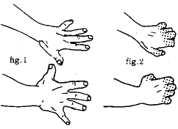
1. Separate and straighten your fingers until tension of a stretch is felt (fig. 1). Hold for 10 seconds, relax and bend your fingers at the knuckles and hold for 10 seconds (fig. 2). Repeat first outward stretch once more.

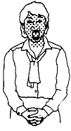
2. This stretch may cause people around you to think you are very strange indeed, but you often find a lot of tension in your face from eye strain. Raise your eyebrows and open your eyes as wide as possible. At the same time, open your mouth to stretch the muscles around your nose and chin and stick your tongue out. Hold this stretch for 5-10 seconds. Caution: If you have clicking or popping noises when opening your mouth, check with your dentist before doing this stretch.

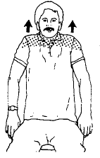
3. Shoulder Shrug: Raise the top of your shoulders toward your ears until you feel slight tension in your neck and shoulders. Hold this feeling of tension for 3-5 seconds, then relax your shoulders downward into their normal position. Do this 2-3 times. Good to use at the first signs of tightness or tension in the shoulder and neck area.

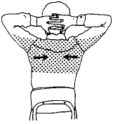
4. With fingers interlaced behind head, keep elbows straight out at sides with upper body in a good aligned position. Now pull your shoulder blades toward each other to create a feeling of tension though upper back and shoulder blades. Hold this feeling of mild tension for 8-10 seconds, then relax. Do several times. This is good to do when shoulders and upper back are tense or tight.

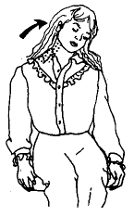
5. Start with head in a comfortable, aligned position. Slowly tilt head to left side to stretch muscles on side of neck. Hold stretch for 10-20 seconds. Feel a good, even stretch and do not overstretch. Then tilt head to right side and stretch. Do 2- 3 times to each side.

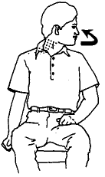
6. From a stable, aligned sitting position turn your chin toward your left shoulder to create a stretch on the right side of your neck. Hold right stretch tensions for 10-20 seconds. Do each side twice.

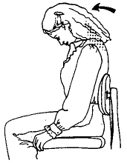
7. Gently tilt your head forward to stretch the back of the neck. Hold for 5-10 seconds. Repeat 3-5 times. Hold only tensions that feel good. Do not stretch to the point of pain.

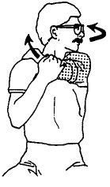
8. Hold your left arm just above the elbow with the right hand. Now gently pull elbow toward opposite shoulder as you look over your left shoulder. Hold stretch for 15-20 seconds. Do both sides.

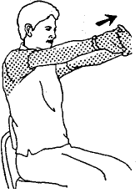
9. Interlace fingers, then straighten arms in front of you. The palm should be facing away from you as you do this stretch. Feel stretch in arms and through the upper part of the shoulder blades. Hold stretch for 10-15 seconds. Do at least two times.

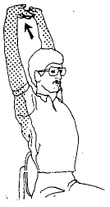
10. Interlace fingers then turn palms upwards above your head as you straighten your arms. Think of elongating your arms as you feel a stretch through arms and upper sides of rib cage. Hold for 10-20 seconds. Hold only stretches that feel relaxing. Do three times.

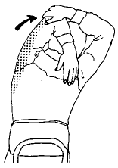
11. Hold left elbow with right hand, then gently pull elbow behind head until an easy tension-stretch is felt in shoulder or back of upper arm (triceps). Hold easy stretch for 30 seconds. Do not overstretch. Do both sides.

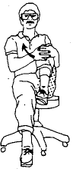
12. Hold onto your lower leg just below the knee. Gently pull bent leg toward your chest and isolate a stretch in the side of your upper leg. Make use of the right arm to pull bent leg towards the opposite shoulder. Hold for 10-20 seconds at easy stretch tension. Do both sides.

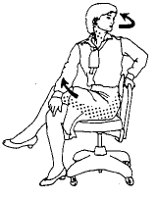
13. A stretch for the side of hip, lower and middle of back. Sit with left leg bent over right leg, then rest elbow for forearm of right arm on the outside of the upper thigh of the left leg. Now apply some controlled, steady pressure toward the right with the elbow or forearm. As you do this, look over your left shoulder to get the stretch feeling. Do both sides. Hold for 15 seconds.

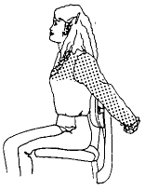
14. The next stretch is done with fingers interlaced behind your back. Slowly turn your elbows inward while straightening your arms. An excellent stretch for shoulders and arms. This is good to do when you find yourself slumping forward from your shoulders. This stretch can be done at any time. Hold for 5-15 seconds. Do twice.

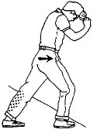
15. To stretch your calf, stand a little way from a wall for solid support and lean on it with your forehead resting on your hands. Bend over and place your foot on the floor in front while leaving the other leg straight. Slowly move your hips forward until you feel a stretch in the calf of your straight leg. Be sure to keep the heel of the foot of the straight leg on the floor and your toes pointed straight ahead. Hold an easy stretch for 30 seconds. Stretch both legs.
