Electronic Personnel Action Forms (EPAF)
Default Routing Queue Setup
Setting up default routing queues for all of the EPAF Approval Categories will save time by automatically populating each time you create an EPAF.
- Click on the EPAF tile on your mynmu.

- Select EPAF Originator Summary
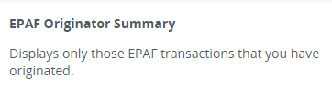

- Select Default Routing Queue
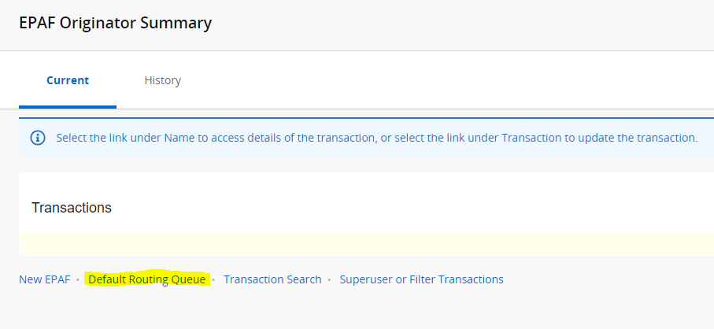

- Select the EPAF approval Category from the dropdown box and click “Go” to populate the approval queue levels.

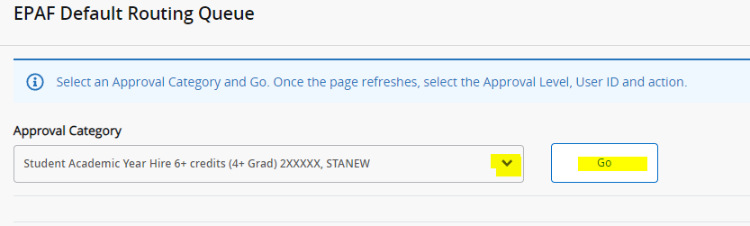

- Fill in the approval level, user name and required action and then save changes. Repeat steps for other EPAF approval categories for which you want to setup default routing queues.

